# Appendix B - Offerings Overview

In this section, we have provided an overview of our company in detail.

Services Offering

BCT’s services encompass the entire lifecycle of technologies and applications in the enterprise from Strategy to Support.

Successful Strategic Partnerships and Joint Ventures

BCT is Technology agnostic and works with the customer invested tools and technologies to maximize ROI. While we partner with most of the best of the breed vendors across the technology stack, we have a very customer focused approach and believe in value delivered to the customer than promoting our partnerships. Below are some of the tech partnerships active currently. We continue to evolve newer partnerships as needed for maximizing our value delivered.

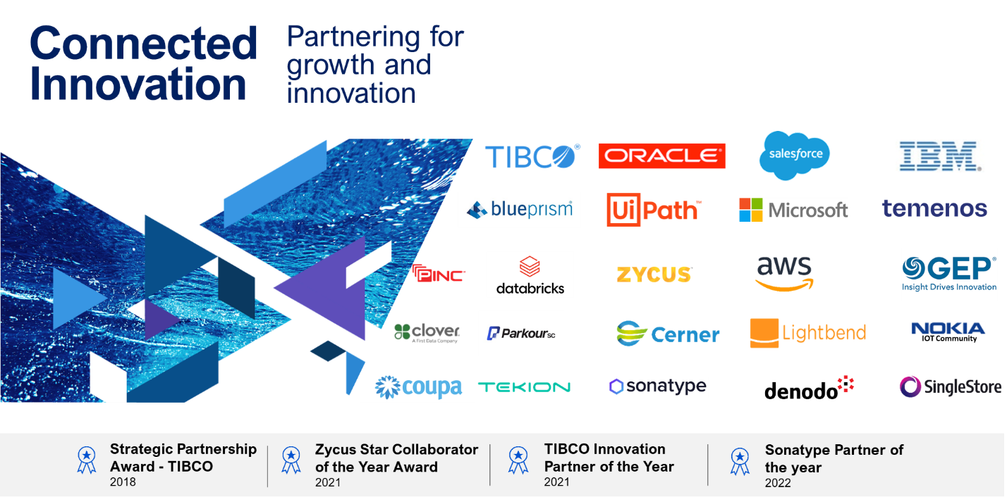

**BCT’s Digital Offerings**

BCT is an IP-led enterprise that combines outcome-based business models, cognitive solutions and growth accelerators to deliver highly differentiated value to customers to help them achieve high levels of efficiency and performance. BCT offers digital solutions in key emerging areas that are seeing increasing demand from large organizations in different verticals.

**Digital Experience**

* **DropThought** is a comprehensive feedback management and intelligence engine that powers businesses to gather instant feedback from their customers, privately. dropthought uses customer sentiment analytics to provide powerful real-time insights. This allows customers and businesses to work together and improve experiences, interactions, events and overall trends
* **dtWorks** - AI-powered customer experience platform designed to streamline business processes and optimize operational efficiency. With advanced analytics, real-time monitoring, and automation, dtWorks enables data-driven decision-making, digitizes complex workflows, and reduces downtime—helping businesses achieve their transformation goals efficiently

**Digital Supply Chain Management**

* **CueTrans** An Integrated digital supply chain management suite of products with powerful HSE driven Journey Management and Track & Trace capabilities. CueTrans has a powerful and robust real-time fleet tracking and monitoring system with advanced tools for geofencing, driver behavior analysis, live monitoring and complete visibility over fleet’s movements and utilization.
* **FuelTrans** is an integrated logistics & transportation solution for Oil Marketing Companies, which offers a 360° view of the entire oil distribution logistics operations. FuelTrans enables Oil Marketing companies to manage and optimize their logistics assets and resources and brings full visibility and automation of the Transportation Process, from request to planning and fulfilment. This system also provides a Secondary Distribution Information Hub that gives a 360° view of oil distribution, logistics, and operations.
* **Procure360** - An integrated AI-powered Supplier Management Solution that enables digital transformation across your entire procurement and vendor value chain, from source to pay

**Predictive Analytics**

* **Retina360 -** Retina360 is an integrated analytics platform with powerful capabilities to collect, validate and process data from multiple data sources and provide multi-parameter predictive modelling, using advanced statistical methods, AI techniques, evolutionary algorithms and constraint optimization tools. Solutions developed on the Retina360 platform work in asset-intensive organizations, helping monitor, maintain and optimize assets for better utilization and performance**.**
* **Rt360** – rt360 is a suite of Risk Management solutions for the BFSI space, commonly known as Regulatory Technology. The suite includes solutions for the management of credit risk, liquidity risk, operational risk and model risk in the banking context.
* **Geodatafy** – an Exploration & Production digitalization platform that provides complete transparency from field to operations through integration of technical data across Oil and Gas business units, such as Drilling, Subsurface, Operations, Finance and HSSE.

Awards and Recognition

Over the years, BCT has been recognized by global industry bodies, partners and customers with prestigious awards.

**Stanford Case Study**

As testimony to its journey over the years, Stanford Graduate School of Business has written two case studies on the evolution of the Bahwan CyberTek Group. The case studies written in 2017 & 2018 are unique in that Bahwan CyberTek is the only company from the region to be featured by Stanford University. Going further BCT’s case study has been included in the curriculum for Management Studies in Stanford in Palo Alto USA and also listed in HBS.

**Awards**

* **Skoch Award for Urban Development, 2023** – BCT’s client, the Directorate of Municipal Administration, won this award.
* BCT TIBCO was one of the winners at **The Economic Times Choice of Tech Leaders 2023 for "Product & Services Strategy"**
* **Excellence in Asset Management & Maintenance Award, 2023** - BCT’s Enterprise Asset Management (EAM) team was recognized with the Excellence in Asset Management and Maintenance Award at the 4th Rail Analysis Innovation & Excellence Summit 2023
* **Outlook Business (Business Icon & Brand of the Year) Award 2022** – Outlook Business recognized Mr. S. Durgaprasad (DP) for his exemplary leadership and BCT for its exceptional commitment to product development.
* **Strategic Technical Partner Award at GITEX Global 2022** - BCT was bestowed with the coveted Strategic Technical Partner Award, presented by Ajman Municipality and Planning Department (AMPD).
* **FICCI Runner-Up Award for Best R&D and Product Development** - retina360, a BCT product, won the prestigious FICCI Runner-up award for the "Best R&D and Product Development” at the 12th edition of the Tanenergy Summit & Awards 2022, organised by The Federation of Indian Chambers of Commerce & Industry (FICCI) Tamil Nadu State Council
* **Sonatype Partner Award 2022** - BCT won the Sonatype EMEA Partner Awards 2022
* **BCT is a Microsoft Gold Partner** - BCT achieved the Gold Partner status with Microsoft for the 9th Consecutive Year
* **Multi-Sectoral Digital Transformation Award at OER Live 2022, Oman** - BCT received the award for ‘Achievements in Multi-Sectoral Digital Transformation’
* **Sir Viswesvaraya Award for 'Best Corporate Entity' from AIMO at TechKnow'22** - BCT was presented with the Sir M. Visvesvaraya Best Corporate Entity Award by the Chief Minister of Tamil Nadu, Mr. MK Stalin at TechKnow 2022
* **FuelTrans won the Confederation of Indian Industries (CII) SCALE 2022** Award for the best “Outstanding Performance” in the supply chain and logistics domain.
* Asia Pacific Enterprise Award for Corporate Excellence, 2021
* Best Service Provider of the Year for Data Analytics (Wind), 2021
* ‘Outstanding Employee Engagement Strategy Award’ and ‘Business HR Award’, 2021
* Best Talent Development Award & the Learning & Development Collaboration Award, 2021
* rt360 recognized as ‘Rising Star of the Year’ at the RiskTech100® 2021.
* FuelTrans wins the prestigious CII SCALE Award for Best Technology Solution Provider, 2021